(Approx. 1005 words)

Online Grocery Shopping
By Tom Burt, Vice President
Sun City Summerlin Computer Club
https://www.scscc.club
tomburt891334 (at) cox.net

One of my recurring weekly activities is provisioning my larder with sufficient food to sustain me for all the activities of retiree life here in Sun City. My weekly meal planning tool, which I wrote in October 2022, is part of this process. You can find that article at: (https://www.scscc.club/Gigabyte_Archives/gg_2022-10Oct.pdf).

Once the week’s meal plan and shopping list are set up and the available specials and coupons (from the stores’ online flyers) have been noted, the next step is ordering the groceries. I usually do the planning on Tuesday and shop online on Wednesday for delivery either Wednesday afternoon or Thursday morning.

Here in Las Vegas, I have paid annual subscriptions for free delivery and various perks with Albertson’s (Fresh Pass) and Walmart (Walmart+). With both, I place my order online via my web browser or with their phone apps; the store’s shoppers do the shopping and bagging, and then a delivery service brings the groceries to my front door. I must order at least $30 at Albertson’s and $35 at Walmart to get free delivery. Both minimums pose a pretty low bar at today’s prices. I have been shopping at Walmart for most staples and Albertson’s for fresh meat.

One of the great features of online grocery shopping is that the stores remember and show you what you’ve ordered, along with current prices and (for Albertson’s) any applicable store coupons. You can reorder things you previously liked or needed (See the Walmart “Reorder” screen below). This also can be a helpful reminder if you’ve forgotten to put something on your shopping list. After a few weeks of shopping, most of your recurring items will be in the “Reorder” or “Buy again” list.

As part of my weekly meal planning cycle, the day before I shop, I check my pantry, freezer, and refrigerator to see if I’m out of anything and to know what items (especially perishables like fresh fruits and vegetables) are already in stock. I don’t want to stock up on things I can’t use up before they spoil. As a solo senior who eats most meals at home, I must be mindful of the quantities on hand. Once my inventory is done, I update my shopping list of things I need to get.

Next, I check the online food pages or websites for specials and coupons. Based on those findings, I may adjust my meal plan and shopping list. I also note savings opportunities where I can buy things for future use (like a super value pack of NY steak that I can break up and freeze or canned soup at half off). Finally, I decided which store (Albertson’s or Walmart) best suits my needs for next week. I rarely shop at both stores in the same week.

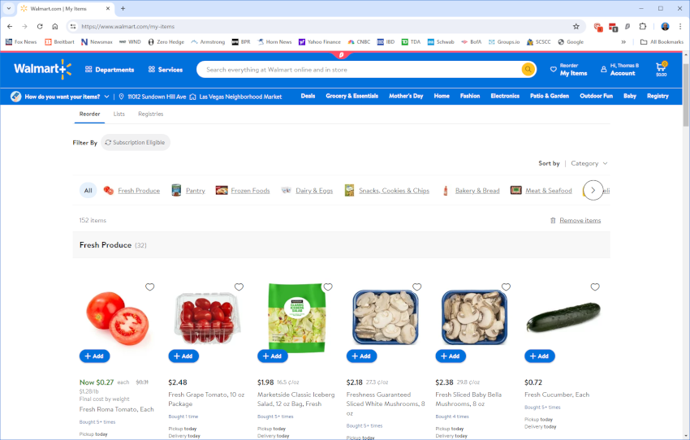

Walmart “Reorder” Screen

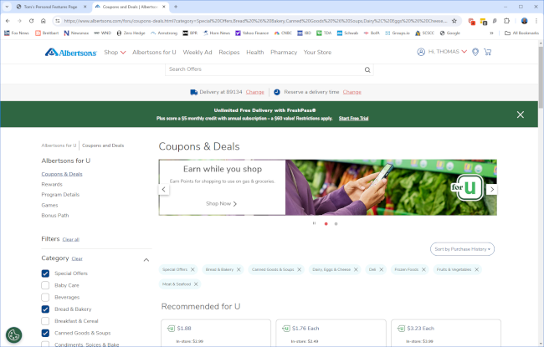

Albertson’s “Albertson’s for U” screen

Walmart doesn’t seem to have store coupons. Prices tend to be the same week-in - week-out, with some food items on sale now and then.

Albertson’s Fresh Pass has an elaborate system of rewards and store coupons that must be reviewed and selected weekly. However, even after choosing the reward or coupon, you must remember to order the item. Selecting the coupon does not automatically add that item to your cart.

The shopping itself is simple. Find an item you want, click the “Add” button, and adjust the quantity if you want more than 1. You can move through your “reorder” list and then return to your shopping list. For anything new, you can use the search window at the top or browse the online store by category or department. Searches can be broad (frozen foods) or narrow (Great Value canned kidney beans).

As you add items, your shopping cart gradually gets fuller. You can view your cart at any time to see what you’ve selected and how much you’ve spent. You can remove items or adjust quantities.

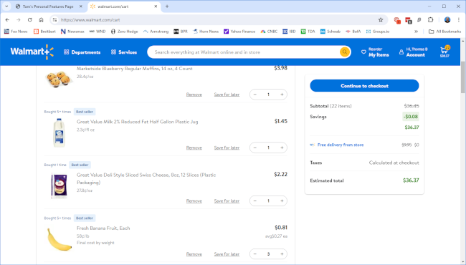

Walmart Shopping Cart

When everything you want has been ordered and double-checked for correctness, including quantities and prices, and the order total is more than the minimum for free delivery, you’re ready to checkout. Click the “Continue to Checkout” button. My screenshots are for Walmart, but Albertson’s are similar.

On the Checkout screen, you choose a preferred delivery date and time from a selection list. These can be a day or two in the future. If ordering early in the day, you may be able to get same-day delivery. You can also pick up the groceries at the store’s pickup depot.

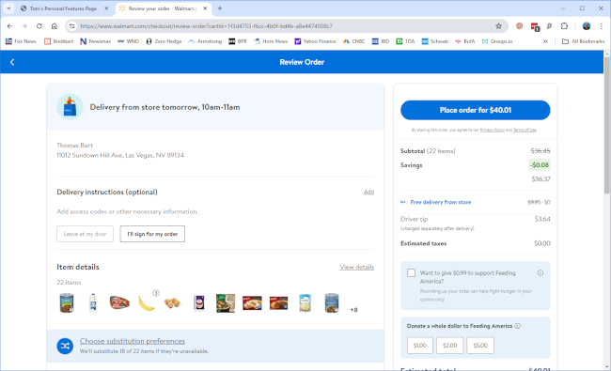

Walmart Final Checkout Screen

Before placing the order, take the time to go through the cart and designate substitutions for the items in your cart. This ensures that the substitution will be to your liking if an item you picked is out of stock when the shopper pulls your order. If you leave it to the store, the substitution will likely be more expensive (and you pay the difference). However, the stores remember previous substitution choices when repeating purchases of the same things. So, after a few cycles, most of the substitutions are already on file. You can choose “don’t substitute” for any item in your cart. If an item is out of stock, that cost is removed from your invoice total.

Be aware that neither Walmart nor Albertson’s will deliver alcoholic beverages. However, you can order them for free pickup at the store’s pickup station, subject to the same order minimums.

Final Thoughts

For those of us who are getting on in years or have difficulty getting out to the stores, the online grocery shopping and delivery services from Walmart, Albertson’s, Smith’s, and other grocery chains are a great convenience. Their “free delivery” services pay for themselves in about ten weeks (actually sooner because you get additional benefits like rewards points or a free subscription to Paramount + streaming). My experience is that they also save me money because I’m much less likely to buy something I don’t need.

